CLI option

curl -sSL -o argocd-linux-amd64 https://github.com/argoproj/argo-cd/releases/latest/download/argocd-linux-amd64
sudo install -m 555 argocd-linux-amd64 /usr/local/bin/argocd
rm argocd-linux-amd64
- hostname -i

ipaddress:8080

- argocd login 172.17.7.152.:8080
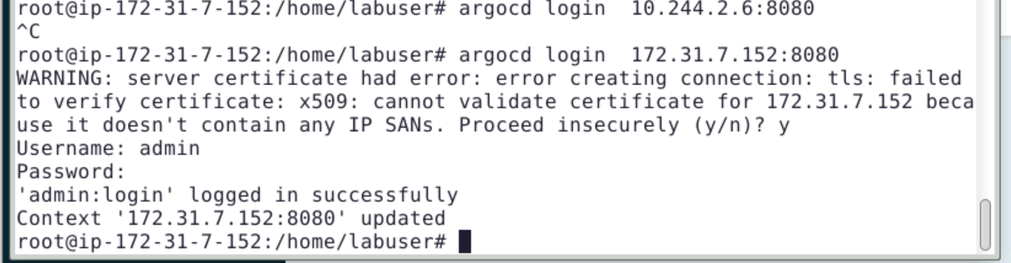
Provide username/password

